**Creating database :**

CREATE schema ormlearn;

use ormlearn;

CREATE table country(co_code varchar(2) primary key, co_name varchar(50));

INSERT into country values ('IN', 'India');

INSERT into country values ('US', 'United States of America');

**Pom.xml**

<?xml version="1.0" encoding="UTF-8"?>

<project xmlns="http://maven.apache.org/POM/4.0.0"

xmlns:xsi="http://www.w3.org/2001/XMLSchema-instance"

xsi:schemaLocation="http://maven.apache.org/POM/4.0.0

https://maven.apache.org/xsd/maven-4.0.0.xsd">

<modelVersion>4.0.0</modelVersion>

<parent>

<groupId>org.springframework.boot</groupId>

<artifactId>spring-boot-starter-parent</artifactId>

<version>3.5.3</version>

<relativePath/>

</parent>

<groupId>com.cognizant</groupId>

<artifactId>orm-learn</artifactId>

<version>0.0.1-SNAPSHOT</version>

<name>orm-learn</name>

<description>Demo project for Spring Data JPA and Hibernate</description>

<properties>

<java.version>21</java.version>

</properties>

<dependencies>

<!-- Spring Boot Starter -->

<dependency>

<groupId>org.springframework.boot</groupId>

<artifactId>spring-boot-starter</artifactId>

</dependency>

<!-- Spring Data JPA -->

<dependency>

<groupId>org.springframework.boot</groupId>

<artifactId>spring-boot-starter-data-jpa</artifactId>

</dependency>

<!-- MySQL JDBC Driver -->

<dependency>

<groupId>com.mysql</groupId>

<artifactId>mysql-connector-j</artifactId>

<scope>runtime</scope>

</dependency>

<!-- Jakarta Persistence API -->

<dependency>

<groupId>jakarta.persistence</groupId>

<artifactId>jakarta.persistence-api</artifactId>

<version>3.1.0</version>

</dependency>

<!-- Spring Boot DevTools -->

<dependency>

<groupId>org.springframework.boot</groupId>

<artifactId>spring-boot-devtools</artifactId>

<scope>runtime</scope>

<optional>true</optional>

</dependency>

<!-- Lombok -->

<dependency>

<groupId>org.projectlombok</groupId>

<artifactId>lombok</artifactId>

<optional>true</optional>

</dependency>

<!-- Testing (Optional) -->

<dependency>

<groupId>org.springframework.boot</groupId>

<artifactId>spring-boot-starter-test</artifactId>

<scope>test</scope>

</dependency>

</dependencies>

<build>

<plugins>

<plugin>

<groupId>org.springframework.boot</groupId>

<artifactId>spring-boot-maven-plugin</artifactId>

</plugin>

</plugins>

</build>

</project>

**Application.properties**

# Spring logs

logging.level.org.springframework=info

logging.level.com.cognizant=debug

# Hibernate SQL logging

logging.level.org.hibernate.SQL=trace

logging.level.org.hibernate.type.descriptor.sql=trace

# Log format

logging.pattern.console=%d{dd-MM-yy} %d{HH:mm:ss.SSS} %-20.20thread %5p %-25.25logger**{25}** %25M %4L %m%n

# DB connection

spring.datasource.driver-class-name=com.mysql.cj.jdbc.Driver

spring.datasource.url=jdbc:mysql://localhost:3306/orm_learn

spring.datasource.username=root

spring.datasource.password=root

# Hibernate config

spring.jpa.hibernate.ddl-auto=validate

spring.jpa.properties.hibernate.dialect=org.hibernate.dialect.MySQL5Dialect

# MySQL DB Config

spring.datasource.driver-class-name=com.mysql.cj.jdbc.Driver

spring.datasource.url=jdbc:mysql://localhost:3306/orm_learn

spring.datasource.username=root

spring.datasource.password=root

# Hibernate

spring.jpa.hibernate.ddl-auto=update

spring.jpa.properties.hibernate.dialect=org.hibernate.dialect.MySQLDialect

spring.jpa.show-sql=true

**Country.java**

package com.cognizant.orm_learn.model;

import jakarta.persistence.Column;

import jakarta.persistence.Entity;

import jakarta.persistence.Id;

import jakarta.persistence.Table;

@Entity

@Table(name = "country")

public class Country {

@Id

@Column(name = "co_code")

private String code;

@Column(name = "co_name")

private String name;

public String getCode() {

return code;

}

public void setCode(String code) {

this.code = code;

}

public String getName() {

return name;

}

public void setName(String name) {

this.name = name;

}

@Override

public String toString() {

return "Country [code=" + code + ", name=" + name + "]";

}

}

**CountryRepository.java**

package com.cognizant.orm_learn.repository;

import com.cognizant.orm_learn.model.Country;

import org.springframework.data.jpa.repository.JpaRepository;

import org.springframework.stereotype.Repository;

@Repository

public interface CountryRepository extends JpaRepository<Country, String> {

}

**CountryService.java**

package com.cognizant.orm_learn.service;

import com.cognizant.orm_learn.model.Country;

import com.cognizant.orm_learn.repository.CountryRepository;

import org.springframework.beans.factory.annotation.Autowired;

import org.springframework.stereotype.Service;

import org.springframework.transaction.annotation.Transactional;

import java.util.List;

@Service

public class CountryService {

@Autowired

private CountryRepository countryRepository;

@Transactional

public List<Country> getAllCountries() {

return countryRepository.findAll();

}

}

**OrmLearnApplicationTests.java**

package com.cognizant.orm_learn;

import com.cognizant.orm_learn.service.CountryService;

import com.cognizant.orm_learn.model.Country;

import org.slf4j.Logger;

import org.slf4j.LoggerFactory;

import org.springframework.boot.SpringApplication;

import org.springframework.boot.autoconfigure.SpringBootApplication;

import org.springframework.context.ApplicationContext;

import java.util.List;

@SpringBootApplication

public class OrmLearnApplicationTests {

private static final Logger LOGGER = LoggerFactory.getLogger(OrmLearnApplication.class);

private static CountryService countryService;

public static void main(String[] args) {

ApplicationContext context = SpringApplication.run(OrmLearnApplication.class, args);

countryService = context.getBean(CountryService.class);

testGetAllCountries();

}

private static void testGetAllCountries() {

LOGGER.info("Start");

List<Country> countries = countryService.getAllCountries();

LOGGER.debug("countries={}", countries);

LOGGER.info("End");

}

}

**MYSQl WorkBench outputs**

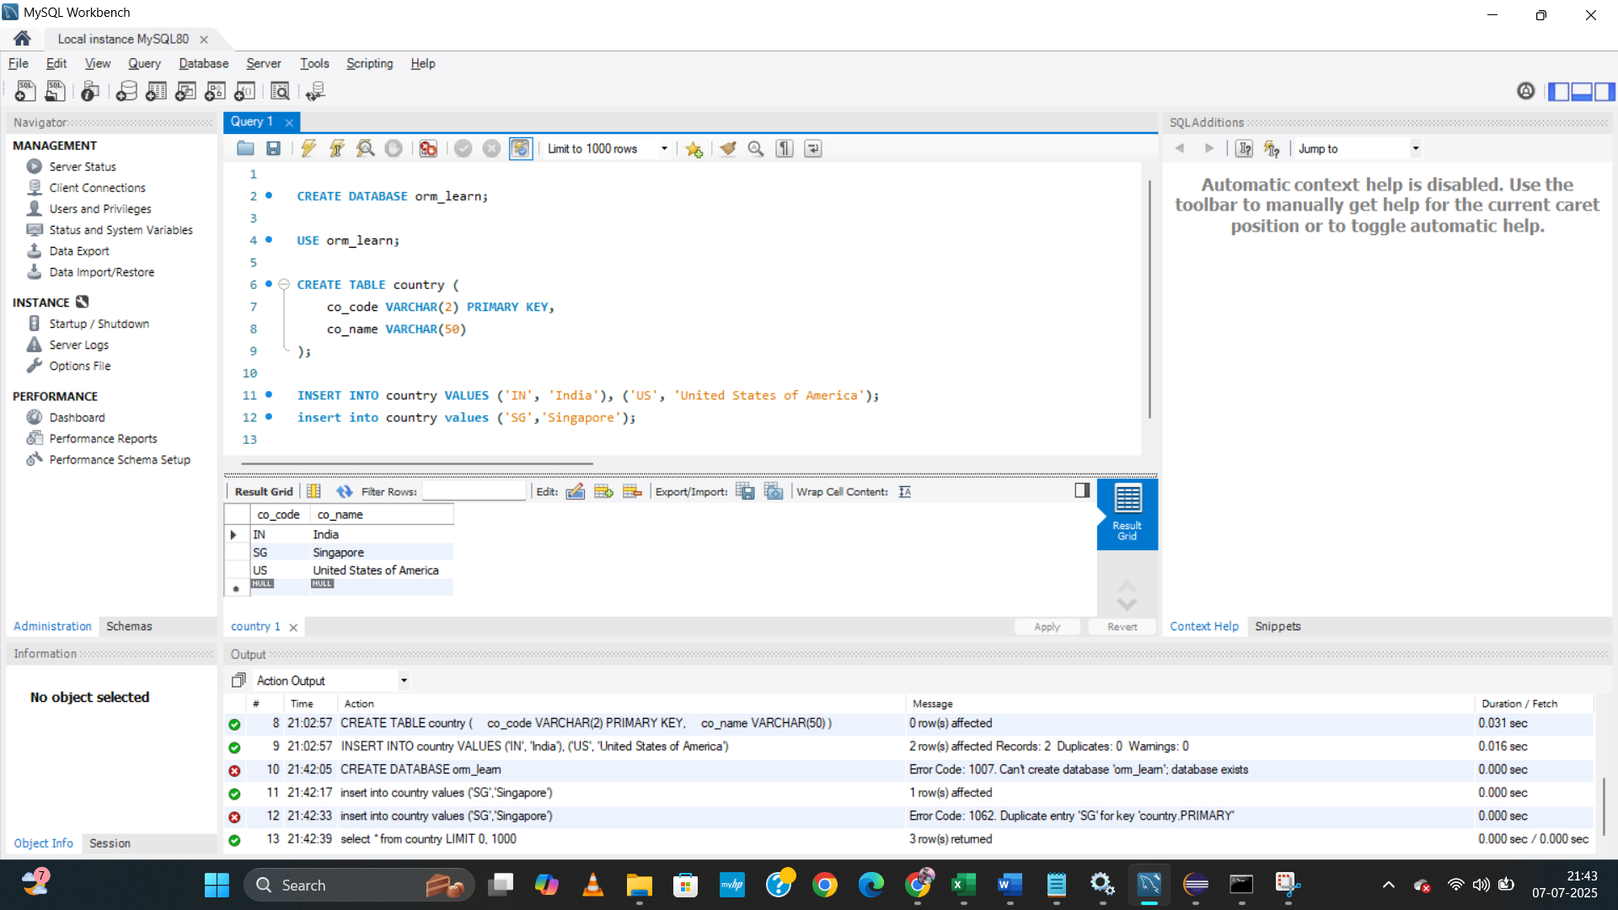

**Spring output**

OUTPUT TEXT FORMAT for your reference

. ____ _ __ _ _

/\\ / ___'_ __ _ _(_)_ __ __ _ \ \ \ \

( ( )\___ | '_ | '_| | '_ \/ _` | \ \ \ \

\\/ ___)| |_)| | | | | || (_| | ) ) ) )

' |____| .__|_| |_|_| |_\__, | / / / /

=========|_|==============|___/=/_/_/_/

:: Spring Boot :: (v3.5.3)

07-07-25 21:44:42.776 restartedMain INFO .OrmLearnApplicationTests logStarting 53 Starting OrmLearnApplicationTests using Java 21.0.3 with PID 19252 (C:\Users\acer\Documents\Week-3-Assessment\Spring-Data-JPA-Handson\Exercise -1\orm-learn\target\test-classes started by acer in C:\Users\acer\Documents\Week-3-Assessment\Spring-Data-JPA-Handson\Exercise -1\orm-learn)

07-07-25 21:44:42.779 restartedMain DEBUG .OrmLearnApplicationTests logStarting 54 Running with Spring Boot v3.5.3, Spring v6.2.8

07-07-25 21:44:42.780 restartedMain INFO .OrmLearnApplicationTests logStartupProfileInfo 652 No active profile set, falling back to 1 default profile: "default"

07-07-25 21:44:42.821 restartedMain INFO ertyDefaultsPostProcessor logTo 252 Devtools property defaults active! Set 'spring.devtools.add-properties' to 'false' to disable

07-07-25 21:44:43.301 restartedMain INFO toryConfigurationDelegate registerRepositoriesIn 145 Bootstrapping Spring Data JPA repositories in DEFAULT mode.

07-07-25 21:44:43.351 restartedMain INFO toryConfigurationDelegate registerRepositoriesIn 213 Finished Spring Data repository scanning in 42 ms. Found 1 JPA repository interface.

07-07-25 21:44:43.778 restartedMain INFO o.h.j.i.util.LogHelper logPersistenceUnitInformation 31 HHH000204: Processing PersistenceUnitInfo [name: default]

07-07-25 21:44:43.834 restartedMain INFO org.hibernate.Version logVersion 44 HHH000412: Hibernate ORM core version 6.6.18.Final

07-07-25 21:44:43.874 restartedMain INFO .i.RegionFactoryInitiator initiateService 50 HHH000026: Second-level cache disabled

07-07-25 21:44:44.196 restartedMain INFO SpringPersistenceUnitInfo addTransformer 87 No LoadTimeWeaver setup: ignoring JPA class transformer

07-07-25 21:44:44.226 restartedMain INFO c.z.h.HikariDataSource getConnection 109 HikariPool-1 - Starting...

07-07-25 21:44:44.604 restartedMain INFO c.z.h.pool.HikariPool checkFailFast 575 HikariPool-1 - Added connection com.mysql.cj.jdbc.ConnectionImpl@d9c96bd

07-07-25 21:44:44.607 restartedMain INFO c.z.h.HikariDataSource getConnection 122 HikariPool-1 - Start completed.

07-07-25 21:44:44.699 restartedMain WARN o.h.orm.deprecation constructDialect 153 HHH90000025: MySQLDialect does not need to be specified explicitly using 'hibernate.dialect' (remove the property setting and it will be selected by default)

07-07-25 21:44:44.722 restartedMain INFO o.h.o.connections.pooling logConnectionInfo 163 HHH10001005: Database info:

Database JDBC URL [Connecting through datasource 'HikariDataSource (HikariPool-1)']

Database driver: undefined/unknown

Database version: 8.0.42

Autocommit mode: undefined/unknown

Isolation level: undefined/unknown

Minimum pool size: undefined/unknown

Maximum pool size: undefined/unknown

07-07-25 21:44:44.742 restartedMain DEBUG h.t.d.s.s.DdlTypeRegistry addDescriptor 64 addDescriptor(12, org.hibernate.type.descriptor.sql.internal.CapacityDependentDdlType@741ad235) replaced previous registration(org.hibernate.type.descriptor.sql.internal.CapacityDependentDdlType@57330b70)

07-07-25 21:44:44.743 restartedMain DEBUG h.t.d.s.s.DdlTypeRegistry addDescriptor 64 addDescriptor(-9, org.hibernate.type.descriptor.sql.internal.CapacityDependentDdlType@499c9596) replaced previous registration(org.hibernate.type.descriptor.sql.internal.CapacityDependentDdlType@23ed4ab4)

07-07-25 21:44:44.744 restartedMain DEBUG h.t.d.s.s.DdlTypeRegistry addDescriptor 64 addDescriptor(-3, org.hibernate.type.descriptor.sql.internal.CapacityDependentDdlType@1c4bf86) replaced previous registration(org.hibernate.type.descriptor.sql.internal.CapacityDependentDdlType@4e634c45)

07-07-25 21:44:44.744 restartedMain DEBUG h.t.d.s.s.DdlTypeRegistry addDescriptor 64 addDescriptor(4003, org.hibernate.type.descriptor.sql.internal.DdlTypeImpl@63fe503a) replaced previous registration(org.hibernate.type.descriptor.sql.internal.DdlTypeImpl@2a0f1e1b)

07-07-25 21:44:44.744 restartedMain DEBUG h.t.d.s.s.DdlTypeRegistry addDescriptor 64 addDescriptor(4001, org.hibernate.type.descriptor.sql.internal.DdlTypeImpl@e93bc53) replaced previous registration(org.hibernate.type.descriptor.sql.internal.DdlTypeImpl@5ac6d8a0)

07-07-25 21:44:44.744 restartedMain DEBUG h.t.d.s.s.DdlTypeRegistry addDescriptor 64 addDescriptor(4002, org.hibernate.type.descriptor.sql.internal.DdlTypeImpl@4ba82c42) replaced previous registration(org.hibernate.type.descriptor.sql.internal.DdlTypeImpl@19851cea)

07-07-25 21:44:44.744 restartedMain DEBUG h.t.d.s.s.DdlTypeRegistry addDescriptor 64 addDescriptor(2004, org.hibernate.type.descriptor.sql.internal.CapacityDependentDdlType@a675aad) replaced previous registration(org.hibernate.type.descriptor.sql.internal.DdlTypeImpl@66088099)

07-07-25 21:44:44.745 restartedMain DEBUG h.t.d.s.s.DdlTypeRegistry addDescriptor 64 addDescriptor(2005, org.hibernate.type.descriptor.sql.internal.CapacityDependentDdlType@6cc87a26) replaced previous registration(org.hibernate.type.descriptor.sql.internal.DdlTypeImpl@5d1b5919)

07-07-25 21:44:44.745 restartedMain DEBUG h.t.d.s.s.DdlTypeRegistry addDescriptor 64 addDescriptor(2011, org.hibernate.type.descriptor.sql.internal.CapacityDependentDdlType@6d99c225) replaced previous registration(org.hibernate.type.descriptor.sql.internal.DdlTypeImpl@4fb79b47)

07-07-25 21:44:45.490 restartedMain INFO .p.i.JtaPlatformInitiator initiateService 59 HHH000489: No JTA platform available (set 'hibernate.transaction.jta.platform' to enable JTA platform integration)

07-07-25 21:44:45.534 restartedMain INFO rEntityManagerFactoryBean buildNativeEntityManagerFactory 447 Initialized JPA EntityManagerFactory for persistence unit 'default'

07-07-25 21:44:45.888 restartedMain WARN .OptionalLiveReloadServer startServer 62 Unable to start LiveReload server

07-07-25 21:44:45.907 restartedMain INFO .OrmLearnApplicationTests logStarted 59 Started OrmLearnApplicationTests in 3.531 seconds (process running for 4.064)

07-07-25 21:44:45.916 restartedMain INFO c.c.o.OrmLearnApplication testGetAllCountries 28 Start

07-07-25 21:44:46.100 restartedMain DEBUG org.hibernate.SQL logStatement 135 select c1_0.co_code,c1_0.co_name from country c1_0

Hibernate: select c1_0.co_code,c1_0.co_name from country c1_0

07-07-25 21:44:46.139 restartedMain DEBUG c.c.o.OrmLearnApplication testGetAllCountries 30 countries=[Country [code=IN, name=India], Country [code=SG, name=Singapore], Country [code=US, name=United States of America]]

07-07-25 21:44:46.139 restartedMain INFO c.c.o.OrmLearnApplication testGetAllCountries 31 End

07-07-25 21:44:46.143 licationShutdownHook INFO rEntityManagerFactoryBean destroy 660 Closing JPA EntityManagerFactory for persistence unit 'default'

07-07-25 21:44:46.146 licationShutdownHook INFO c.z.h.HikariDataSource close 349 HikariPool-1 - Shutdown initiated...

07-07-25 21:44:46.152 licationShutdownHook INFO c.z.h.HikariDataSource close 351 HikariPool-1 - Shutdown completed.